# **Group 4**

# **COMP 390**

# **Group Project:**

# Job Market Place

**Group Members:**

1. **Samuel Njau S13/04319/21**
2. **Ramon Thumbi S13/04361/21**
3. **Valarie Atieno S13/04398/21**
4. **Stephen Thiong'o S13/04394/21**
5. **Loreen Jane Okumu S13/04355/21**
6. **Peter Osembe Otieno S13/04530/21**

Table of Contents

Group Project: 1

Job Market Place 1

Job Market Place System Report 3

Introduction 3

System Overview 3

Functionality 3

Security Measures 3

Technical Details 4

System Architecture 4

Data Management 5

Conclusion 5

Appendix: Visual Representations 5

Job Listing 6

Job Filtering 6

User Authentication 7

Job Application/Bid Submission 7

Employer Dashboard 8

Application Tracking 8

# Job Market Place System Report

## Introduction

The Job Market Place system is a web-based platform designed to facilitate the connection between potential employees and employers. Developed using the PHP Laravel framework, this system adheres to the Model-View-Controller (MVC) architectural pattern, ensuring a scalable and maintainable codebase.

### System Overview

### Functionality

The system provides the following key functionalities:

* **Job Listing:** Employers can post job listings, specifying details such as job title, description, required qualifications, experience, and salary.
* **Job Filtering:** Users can filter job listings based on categories, experience level, and salary range to find relevant opportunities.
* **Job Search:** Users can search for specific job listings using keywords through the search bar.
* **User Authentication:** Authentication functionality ensures secure access to features such as job application and bid submission.
* **Job Application:** Potential employees can apply for jobs by submitting their resumes (CVs) and expected salary.
* **Bid Submission:** Applicants can place bids on job listings, indicating their desired compensation.
* **Employer Dashboard:** Employers have access to a dashboard where they can manage their job postings, view received bids, and edit job listings.
* **Application Tracking:** Applicants can track the status of their job applications through the "Applications" section.

### Security Measures

The system incorporates various security measures to protect user data and ensure confidentiality:

* **Authentication:** User authentication is implemented to control access to sensitive features and data.
* **Input Validation:** Form inputs are validated to prevent injection attacks and ensure data integrity.
* **Secure Report Generation:** The system utilizes the FPDF library for generating reports, ensuring secure and reliable document generation.
* **Database Security:** Data is securely stored in databases with appropriate encryption and access controls.
* **Session Management:** Sessions are managed securely to prevent session hijacking and ensure user privacy.

### Technical Details

Technology Stack:

* Framework: PHP Laravel
* Database: MySQL
* Frontend: HTML, Tailwind CSS, Alpine JavaScript
* PDF Generation: FPDF Library

### System Architecture

The system follows the Model-View-Controller (MVC) architectural pattern, separating the application logic into three distinct layers:

* **Model:** Represents the data and business logic of the application, including database interactions and validation rules.
* **View:** Presents the user interface to interact with the system, including job listings, forms, and dashboards.
* **Controller:** Handles user requests, processes input data, and coordinates interactions between the model and view components.

### Data Management

* Database Schema: The system's database schema is designed to efficiently store and retrieve job listings, user information, bids, and application data.
* Data Seeding: Initial data is seeded into the database to provide sample job listings and user accounts for testing purposes.
* Data Validation: Input validation is implemented to ensure the integrity and consistency of data stored in the database.

## Conclusion

The Job Market Place system is a robust and secure platform that streamlines the process of job searching and recruitment. Built on the PHP Laravel framework, the system offers a user-friendly interface, advanced search capabilities, and comprehensive security features to protect user data. With its scalable architecture and customizable functionalities, the Job Market Place system is poised to meet the needs of both employers and job seekers in the dynamic job market landscape.

# Appendix: Visual Representations

### Job Listing

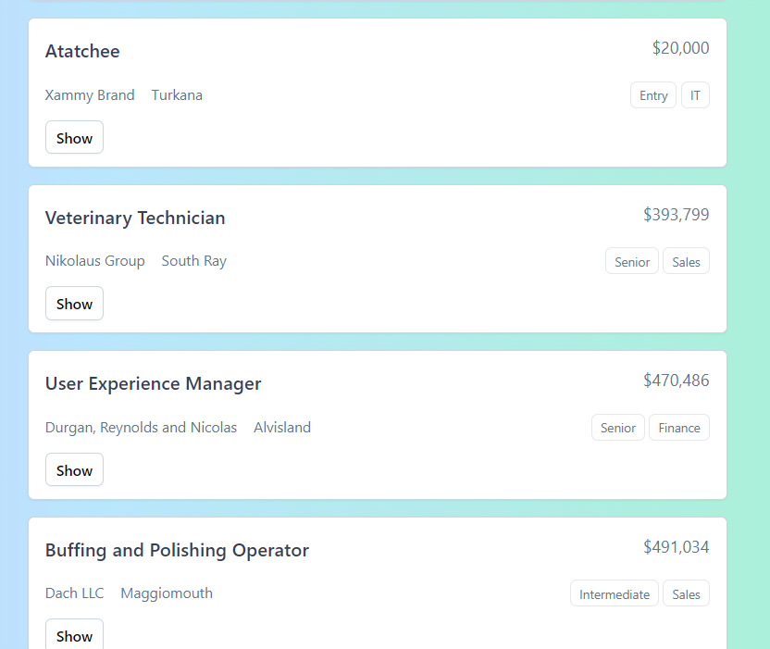

Figure 1: Job Listing Interface

### Job Filtering

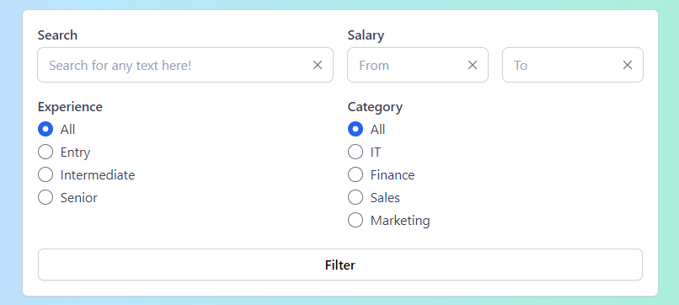

Figure 2: The Jobs Filtering card component.

### User Authentication

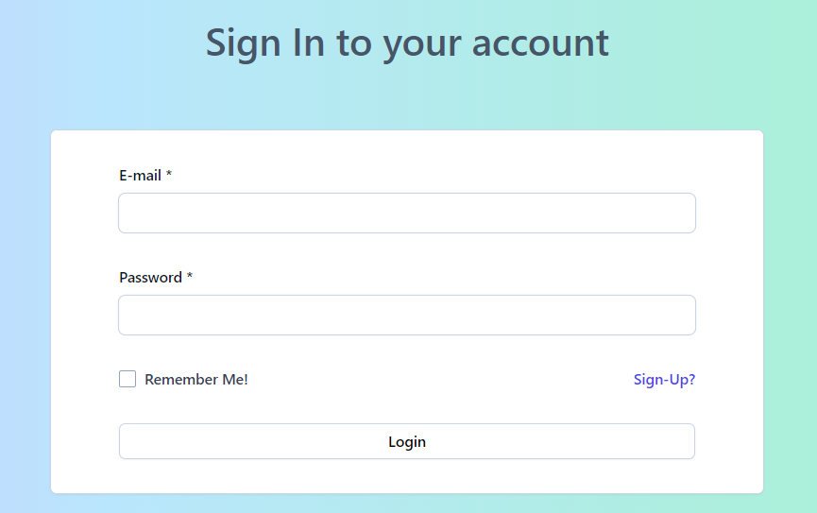

Figure 3: Users are authenticated through the sign-in form.

### Job Application/Bid Submission

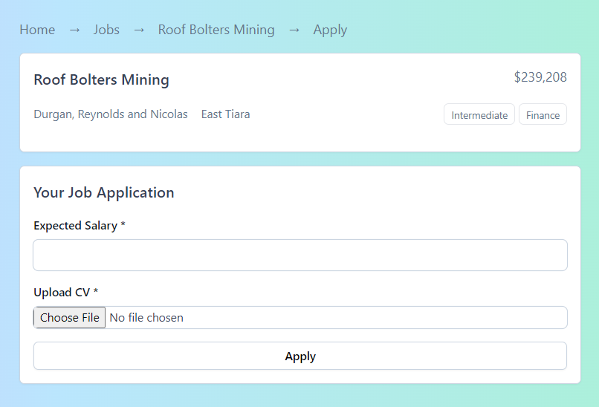

Figure 4: This is how a user applies to a job.

### Employer Dashboard

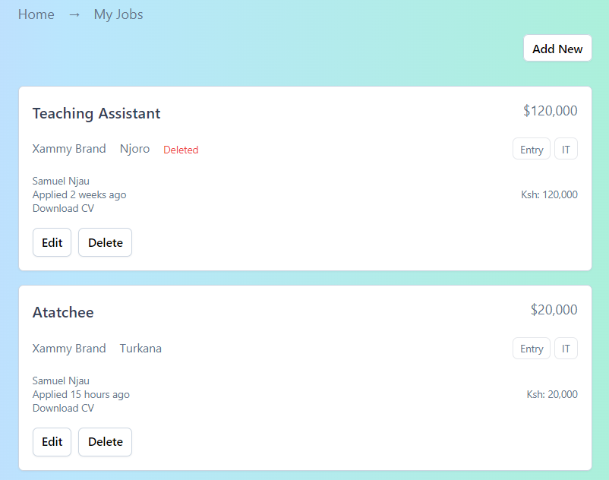

Figure 5: This is the employer dashboard where Jobs are managed.

### Application Tracking

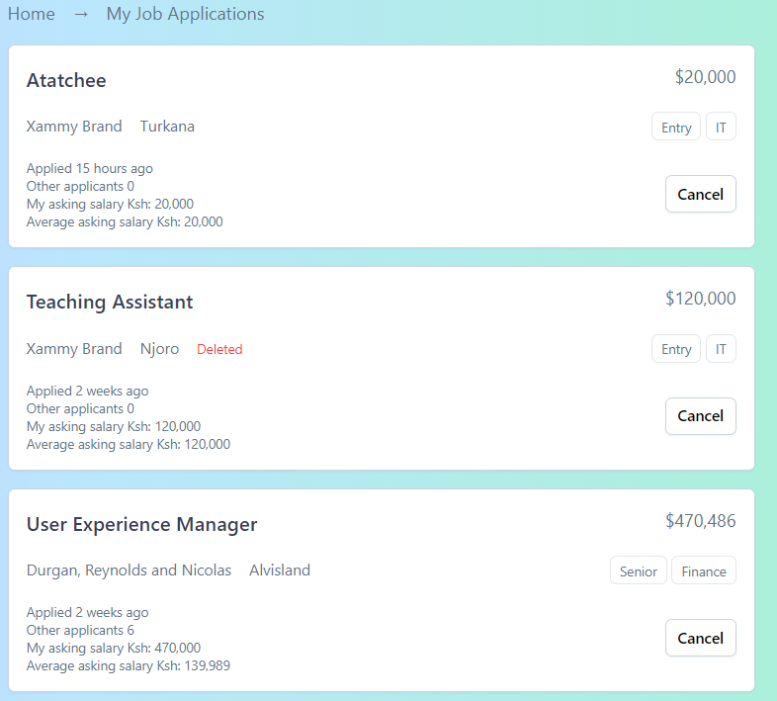

Figure 6: This is the bidders dashboard where applications are managed.